# **Chapter 4**

**SYSTEM CODE GENERATION AND TESTING, CONCLUSIONS AND RECOMMENDATIONS**

## **4.1 Introduction**

This chapter contains the sample code of the system in terms of functions and the various test plans that were carried out to make sure that the system was functioning as expected and undertaking the various activities in the correct manner. The chapter also contains the challenges faced during system development and the recommendations suggested.

## **4.2 Code generation**

Below are sample codes that are contained in the system that represent then various functionalities

## **4.3 Development Tools**

### **4.3.1 Android Software Development Kit**

The Android Software Development Kit (SDK) is freely available and downloadable from Android’s website. This SDK provides developers with the API libraries and tools necessary to build test and debug applications for Android. Several thing need to be considered before downloading and installing SDK, these include the checking for compatibility in terms of physical requirements.

### **4.3.2 Firebase**

Firebase provides support for Android applications and other application such as web applications. Firebase also provides authentication with google services. Firebase helps power the application backend by providing data storage, providing user authentication, static hosting for the data such that it can be accessible everywhere. More the firebase Realtime database provides Realtime information and data when there’s change in the data stored

### **4.3.3 Testing Devices**

The testing was done on an android device running on Android Operating system Android version 6.0

### **4.3.4 Storage Devices**

There was need for project files transfer, this could be done using a flash disk, Hard Disk or a CD,  
and also for keeping back up files in case of the loss of the original copy. Other cloud storage  
applications are alternative, Google drive, or even GitHub.

**4.3.6 Computer**A Personal computer that supports Android studio with a minimum RAM of 4GB, processing  
power 2.0 Ghz and greater and sufficient storage space for files storage.  
**4.3.7 Android Studio**An open source Integrated Development Environment (IDE) for Android application development,  
based on IntelliJ IDEA with powerful code editor and developer tools with assistance, Android  
Studio offers even more features that enhance your productivity when building Android apps.  
**4.3.8 Internet Browser**Used for the setup and configuration of Firebase console and viewing various items in the firebase backend such as authentication.  
**4.4 Development Languages**JAVA programming language was used for the development of the communication between different activities, while XML was used for the generation of the Graphical user interface.

## **4.5 Testing**

Testing was done to determine whether the system was meeting the requirements, it was done after the system was put in place

### **4.5.1 Test plan**

The Software Test Plan is designed to prescribe the scope, approach, resources, and schedule of all testing activities. The plan will identify items to be tested, the features to be tested, the types of testing carried out, the personnel responsible for testing, the resources and schedule required to complete testing.

**Objectives of Testing**

1. To achieve the correct code and ensure all Functional and Design requirements are implemented as specified in the documentation.
2. To provide a procedure for Unit and System Testing.
3. To identify the test methods for Unit and System Testing.

### **4.5.2 Test Results**

### **GUI testing**

This was done to ensure that first the navigation within the interface was easy and that

the color used in the entire system and ensuring that the sequencing of events was

proper and happened as specified.

#### **Test case 1**

#### **Error generation**

Expected outcomes:

Proper errors and warning with appropriate error and warning messages should be generated in the case that the user performs a wrong operation or an operation that transforms the database from one consistent state to another, for instance entering wrong password, and the errors generated should be in an appropriate color.

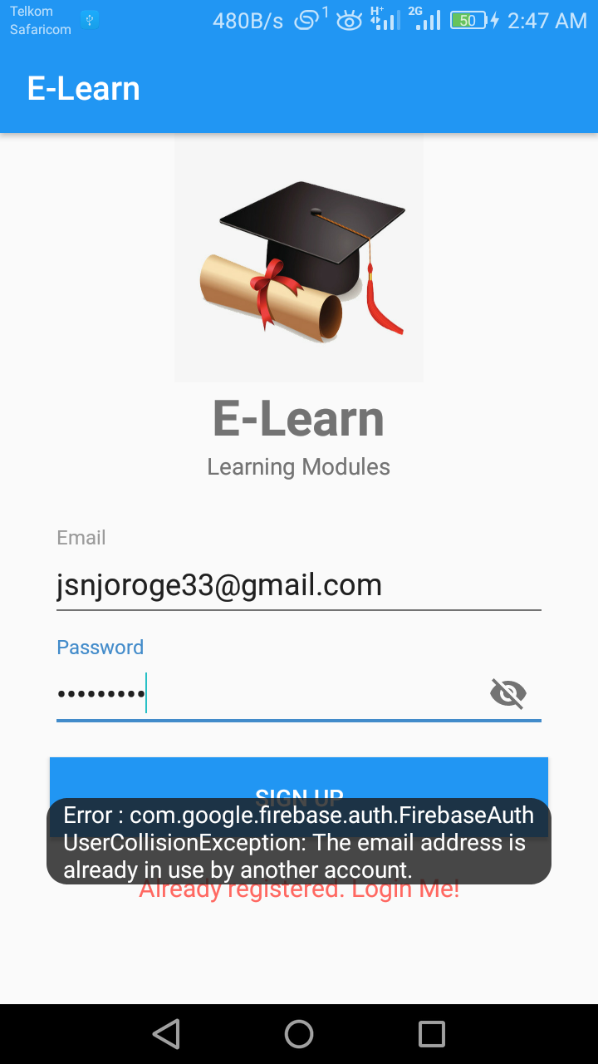

Actual outcomes:

Proper errors and warning were generated when the user performed a wrong operation and suggest the right action. The font of the generated errors was in the color red and a white for warnings.

### **Test case 2**

##### **Confirmation messages**

Expected outcomes:

The user should receive confirmation messages that is some form of feedback on an action he or she carried out on the system for example successful log in.

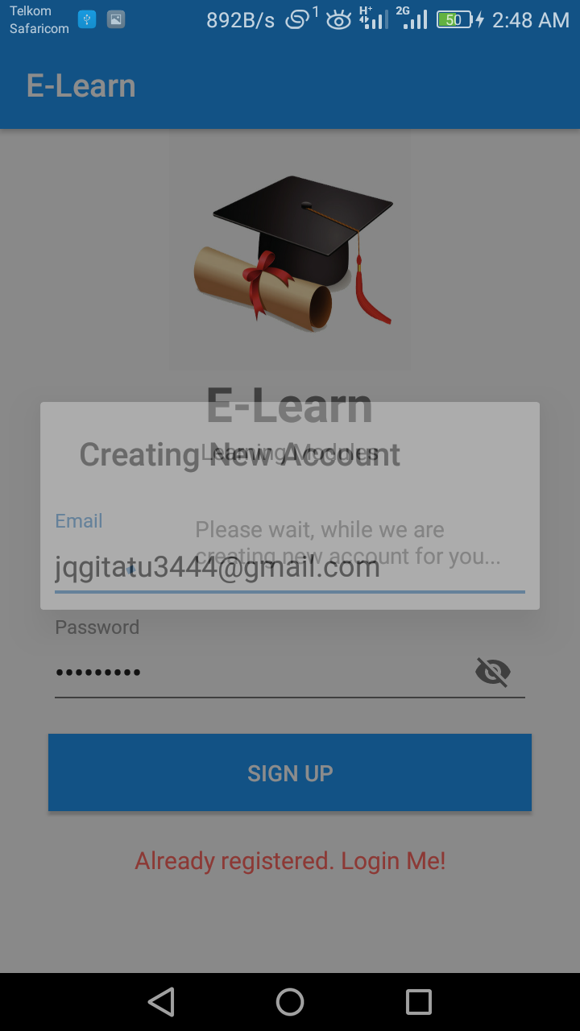

Actual outcomes:

Confirmation messages for all major operations are generated as some form of feedback to the user confirming their action.

### **Test case 3**

##### **Navigation Verification 1**

Expected outcome

All links or buttons provided on the GUI should lead to the locations where they are really supposed to lead to, both internally and externally, and not wrong destinations.

Actual outcome:

All links or buttons on the GUI lead to the correct destinations and are working appropriately.

#### **Navigation Verification 2**

Expected outcome

Users should be able to view login credentials to confirm, if need be, that they have provided the correct details. They should also be able to view the same credentials, recover accounts after forgetting the password.

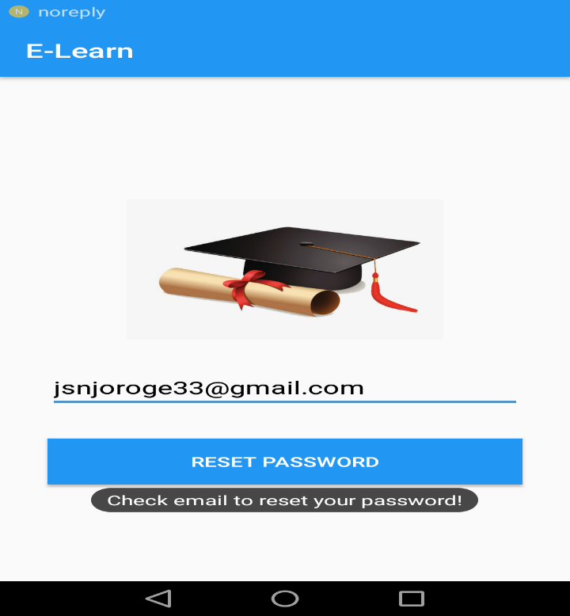

Actual outcome:

The users were able to:

1. Recover account after forgetting passwords
2. Change credentials such as password

### **Module Testing**

The modules in the interface were tested to ensure that information properly flowed and each task in the module was displayed as expected.

|  |  |  |  |
| --- | --- | --- | --- |
| Type of Test | Area To be Tested | Given Result | Expected Results |
| Module Testing | Adding new user module (account registration) | The system interface was able to add new user into the system | The system interface should be able to add new users into the system |
| Course display module | the interface displayed each unit together with relevant materials for that unit | The system interface should display each course unit and relevant notes of that unit. |
| Search and give results module | The module was able to search and give results | The search button on the units page should display search result a user searches |

### **Integration Testing**

This is the testing was done to find out whether the various modules making up the system were able to work together and generate the expected results. This was also done to determine whether the client and the server interacted correctly.

|  |  |  |  |
| --- | --- | --- | --- |
| Type of Testing | Area To be Tested | Given Results | Expected Results |
| Integration testing | The login, search, and give results | The system was able to display the various values and items in the database | The system shall be able to search, and give results |

**Acceptance Testing**

This was carried out to test the user acceptance of the system after completion of the system development and testing. It involved introducing the new system to the user and giving them the system performance.

|  |  |  |  |
| --- | --- | --- | --- |
| Types of Test | Areas To be Tested | Given Results | Expected Results |
| User requirements | Finding out whether the system met the specified requirements specified by the user | The system was able to meet most of the given user requirements while others were much complex to achieve due to time factor and others will be recommended to be included in the future | The system should be able to meet a larger part of the requirements specified by the client while still creating room for additional requirements. |
| Black Box testing | Working of the internal structure and design | All internal components were able to communicate effectively | Efficient internal working structure |

### **Functional Testing**

It’s done to validate an application and ensure that the system performs all the expected functionalities correctly. It included testing of each function step by step of each module.

|  |  |  |  |
| --- | --- | --- | --- |
| Type of test | Areas to be tested | Given results | Expected results |
| Functional testing | Entire system | All the deployed functions were able to perform and also interact with the modules contained in the system | All functions should perform and result to the expected outputs and the interaction between the various components. |

## **4.6 Conclusion**

Comparing the existingthe existing web based system this system will provide extra materials for learning to students. I believe the system has met the predefined requirements thus able to perform its function well effectively and efficiently.

USER MANUAL

For user guidance, this is a user manual for new users as well as existing users to ease the

interaction with the application. The manual provides methods of application navigation and

other relevant information.

Installation.

For a new install this application can be acquired from source /third party or get it shared to

you from anyone who has access to it. Alternatively once on Google play store you will be able

to download it yourself. Once you have the application click on the application file in order to

install, allow the necessary permission as requested by the application. Also its important to

ensure there is internet connection.

Navigation

When you already have the application installed, you have two options. For a new User you

have to sign up to create your account. Once you logged in ensure you proceed to settings and

set your security question. Answers to this questions are important when recovering your

account. If you’re already a user you can log in using your email and your account password.